**Question 4:**  (16 Marks)

Install Debian Linux on your system either by setting up a virtual machine or by configuring a dual boot environment. Applied Specification: RAM – 4GB (approx.) 2 Virtual CPU cores 20GB of hard drive

Deliverables:

• A document with screenshots/pictures of each step of the installation process. (You

can also click pictures with your smartphone)

• A brief description of any issues encountered and their resolution.

• Verification of successful installation by providing screenshots of the Debian desktop environment.

**Answer:**

Step 1: Download Debian Iso file from ‘https://www.debian.org/releases/bookworm/debian-installer/’.

I download = ‘https://cdimage.debian.org/debian-cd/current/amd64/iso-cd/debian-12.6.0-amd64-netinst.iso’.

Step 2: Download Virtual box or VMware from their respective sites.

I used VirtualBox download: ‘https://download.virtualbox.org/virtualbox/7.0.20/VirtualBox-7.0.20-163906-Win.exe’.

Step 3: Install Virtual box:

* Click on virtual box installation file.
* Then click on next and leave it as until installation complete, then click on install.

1. 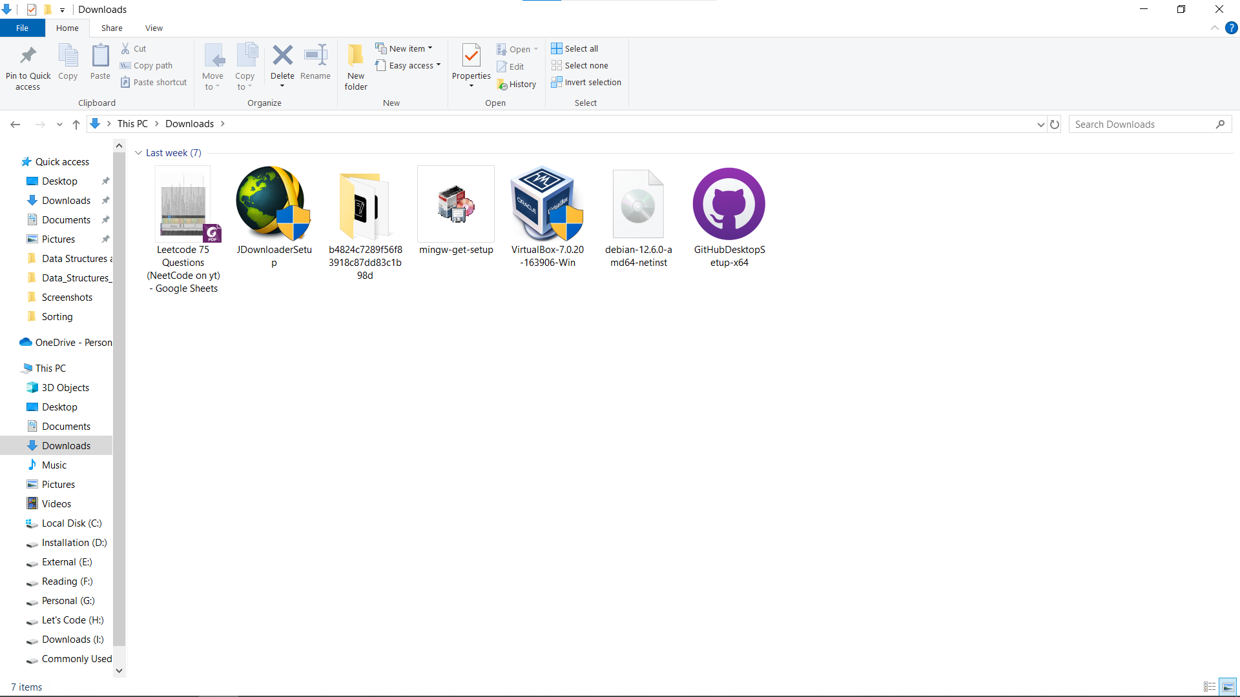



1. 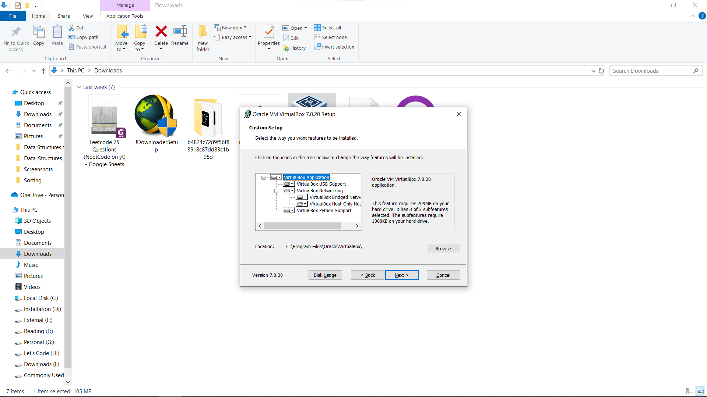
2. 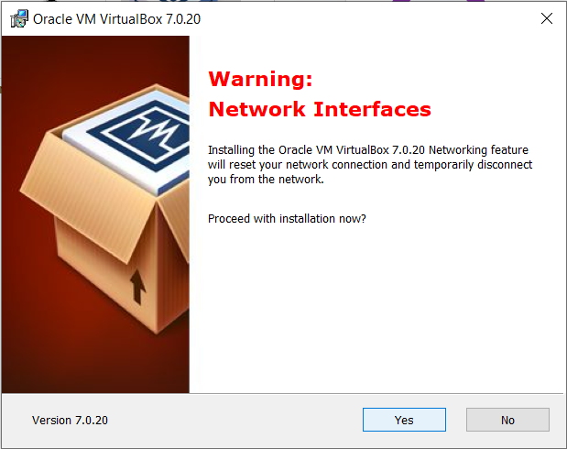
3. 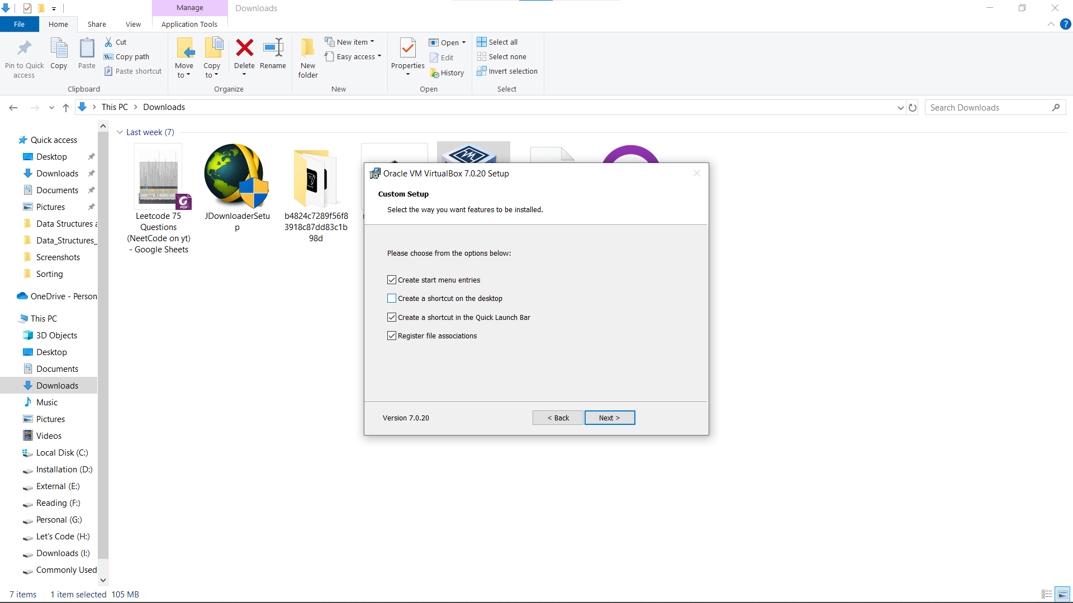
4. 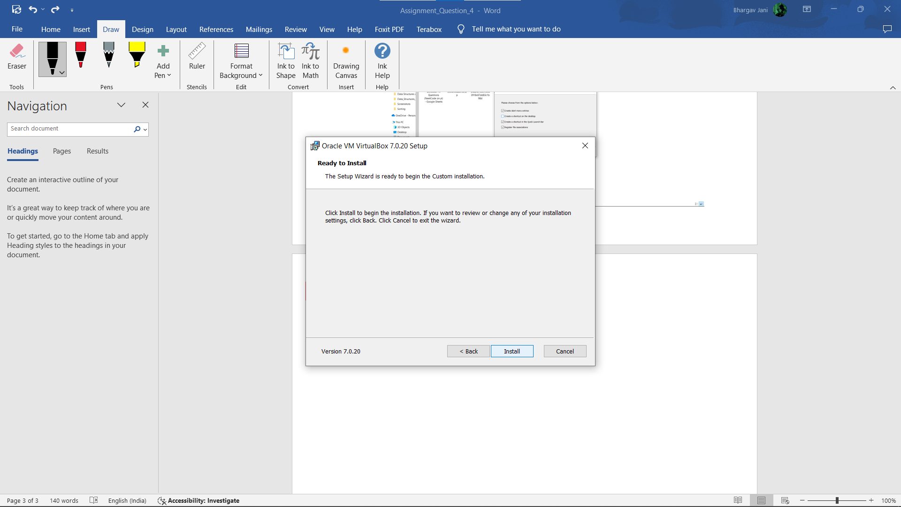
5. 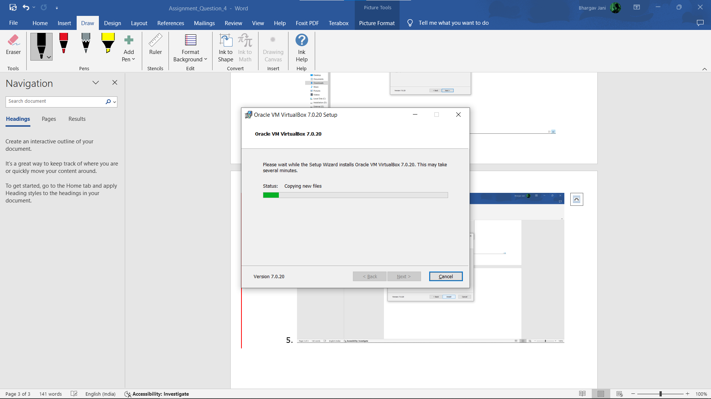

* Click on Finish and Open Virtual box.

1. 



Step 3: Open Virtual Box and Click on new for stabilized new environment for Debian.

1. 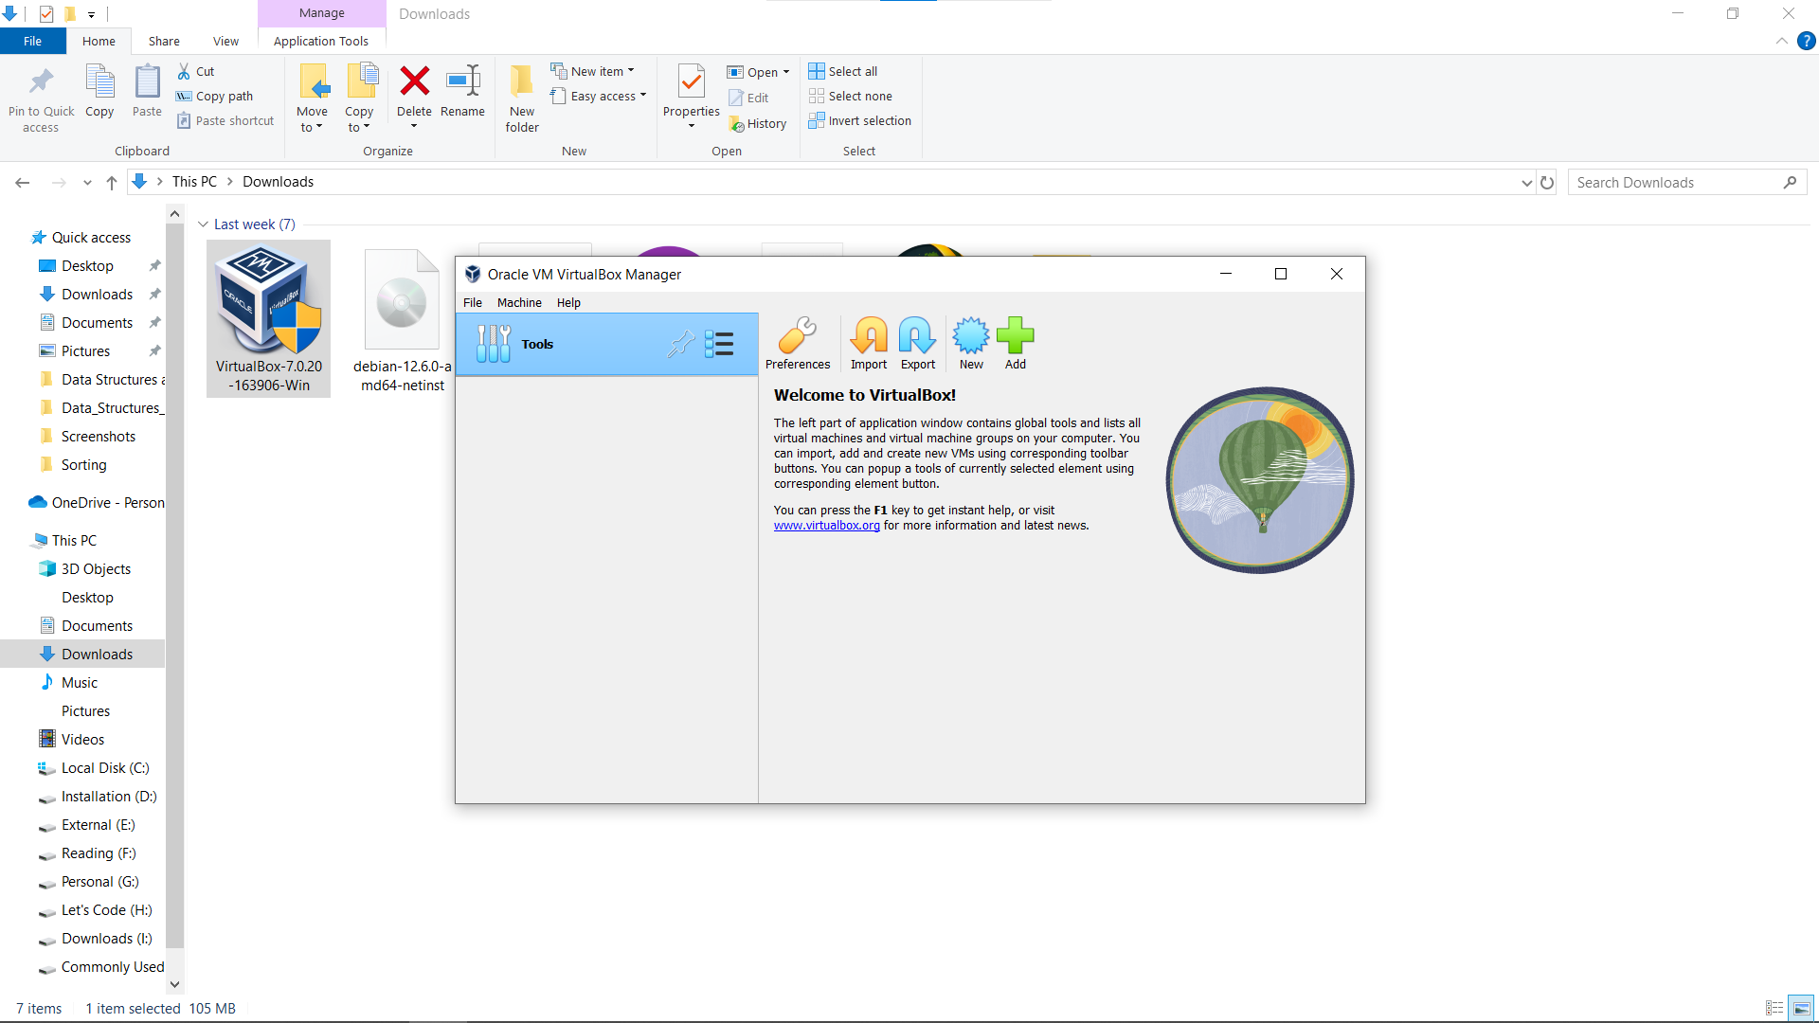



Step 4: After we have to fill given details:

1. 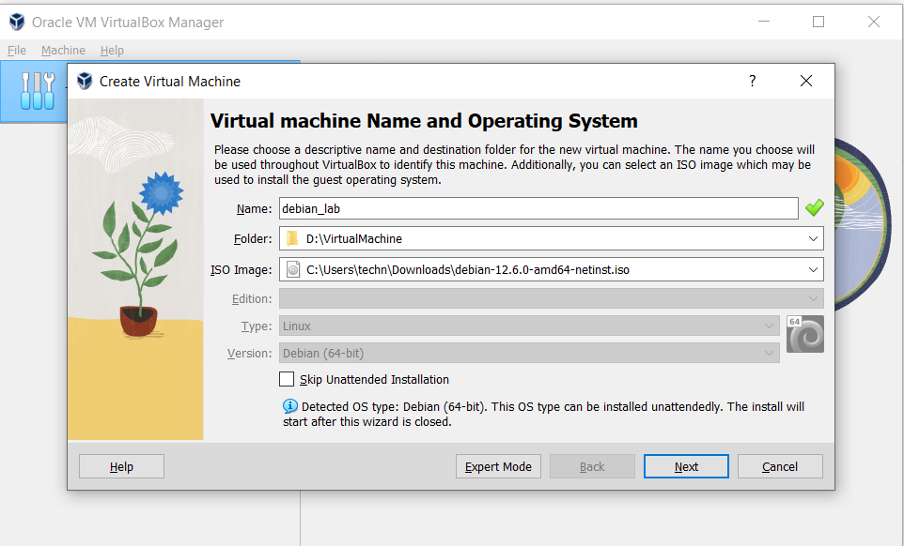



1. Name of your Environment.
2. Select folder where you/we want to stabilize our Debian environment.
3. Here we able to select Iso file its optional:
   1. If select iso files, then step 4 will disabled.
   2. Otherwise, step 5 will be disabled.
4. In this step we choose type of OS and their distribution version. Make sure your selection match with iso file you have to setup.
5. In this step we have an option to check or uncheck:
   1. Checked: provide manually installation.
   2. Unchecked: It will install themselves.

Step 5: Now click on next: In above step I choose ISO file and unchecked box.

1. 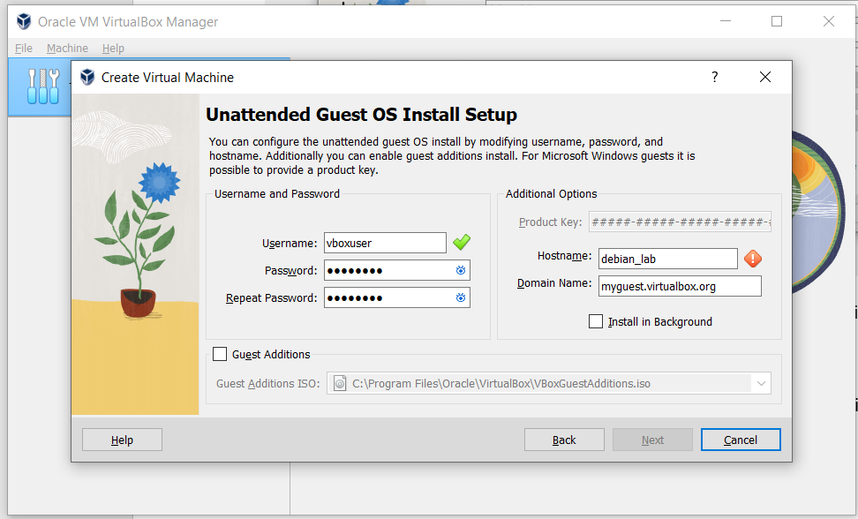



1. In this box we must set username and their password.
2. In this box we provide host name and domain where you want access (not necessary) leave it remains.
3. It is provide change option for iso file.

Step 6: Selecting Hardware option.

* 1. How much memory you want to provide.
  2. How much core/processor you want to provide.
  3. Here another option for selecting EFI which provide to installation or boot iso file using firmware instead of bios.

1. 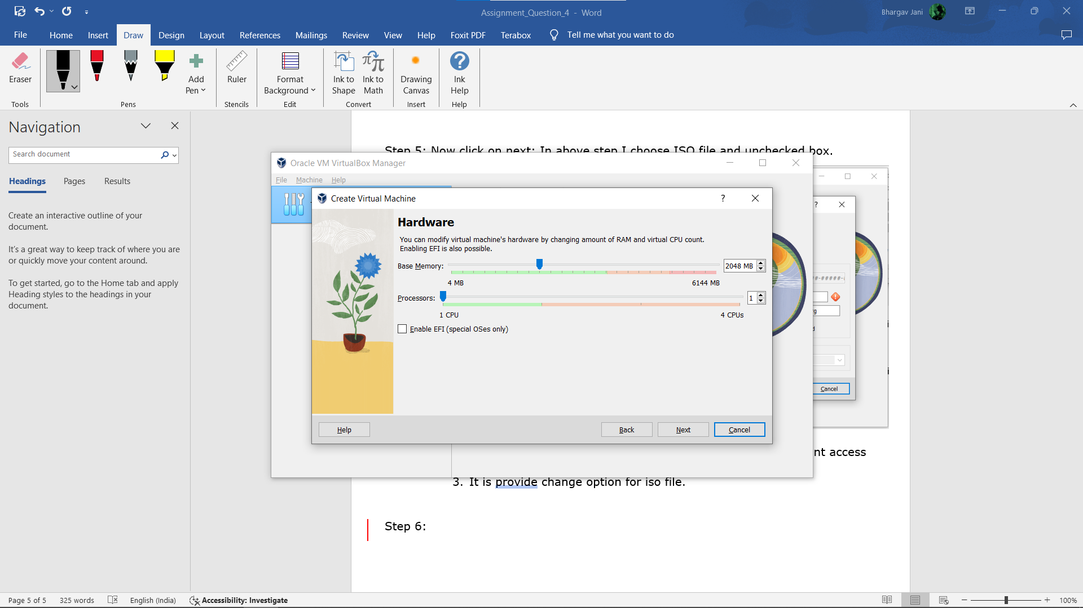

Step 7: Selecting Size of Virtual Disk according to your requirements.

* 1. In first option select virtual hard disk size manually.
  2. Use predefines virtual file.
  3. Third no assign disk size.

1. 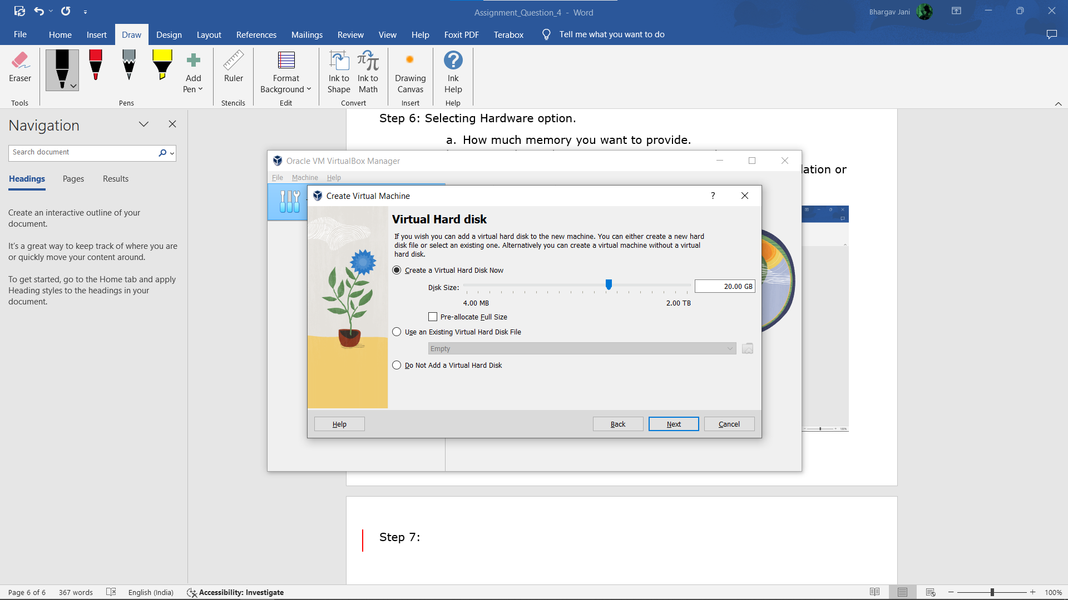

Step 8: Now click on finish in next step.

1. 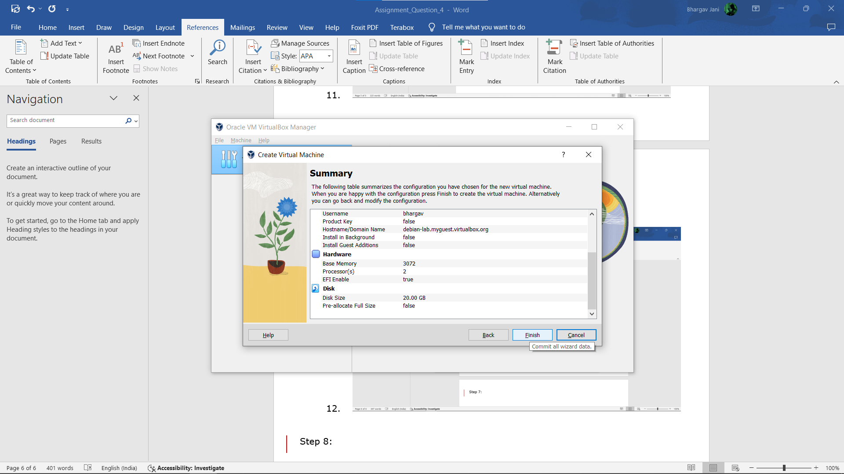

Step 9: After we show virtual box screen like this.

1. 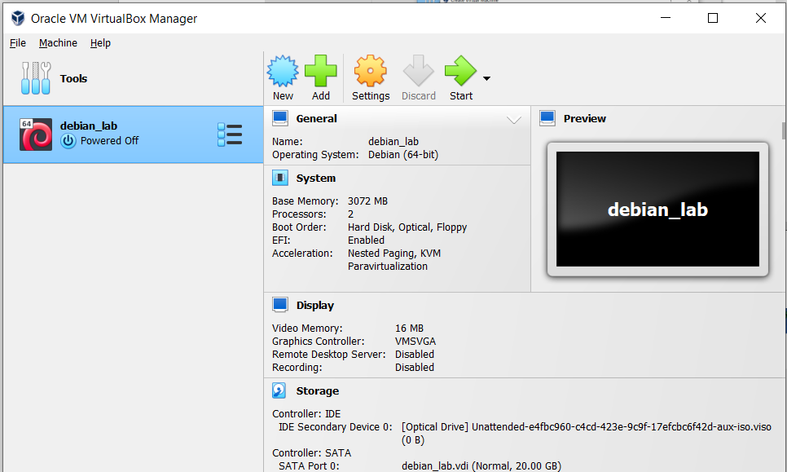

Step 10: Click on Start or double click on environment.

It will install OS themselves.

* In this process install or required packages.
* Copying and extract required zip files.
* Setup boot grab as well.

1. 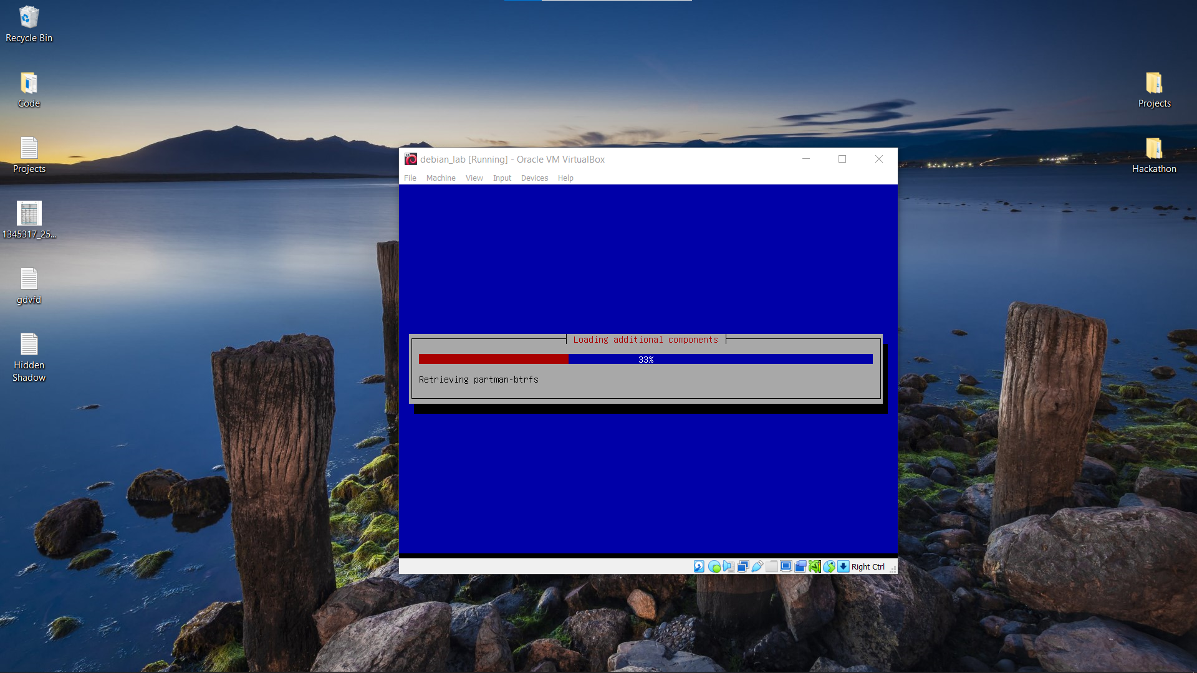
2. 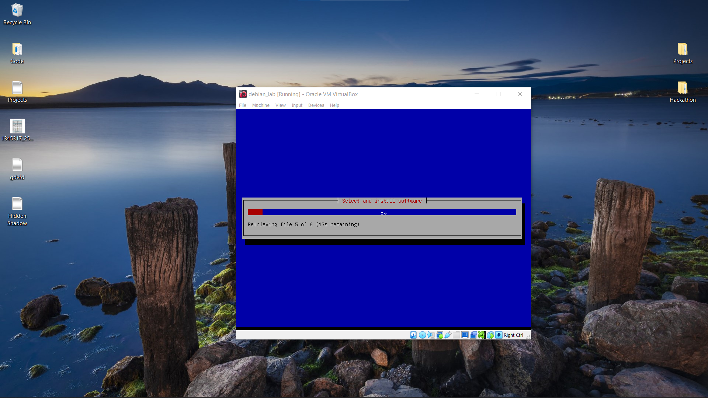
3. 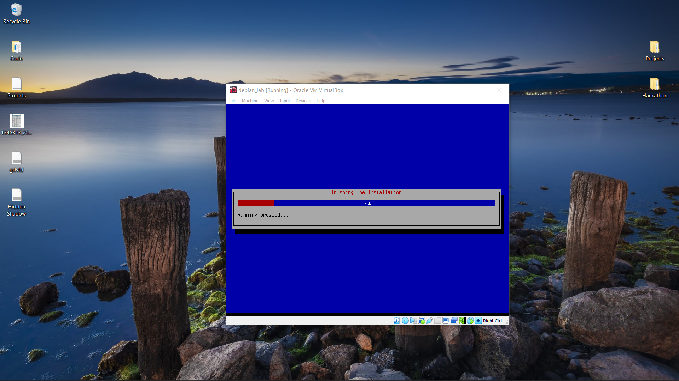

Wait until all process complete.

Step 11: After completing Installation Screen shown like this.

1. 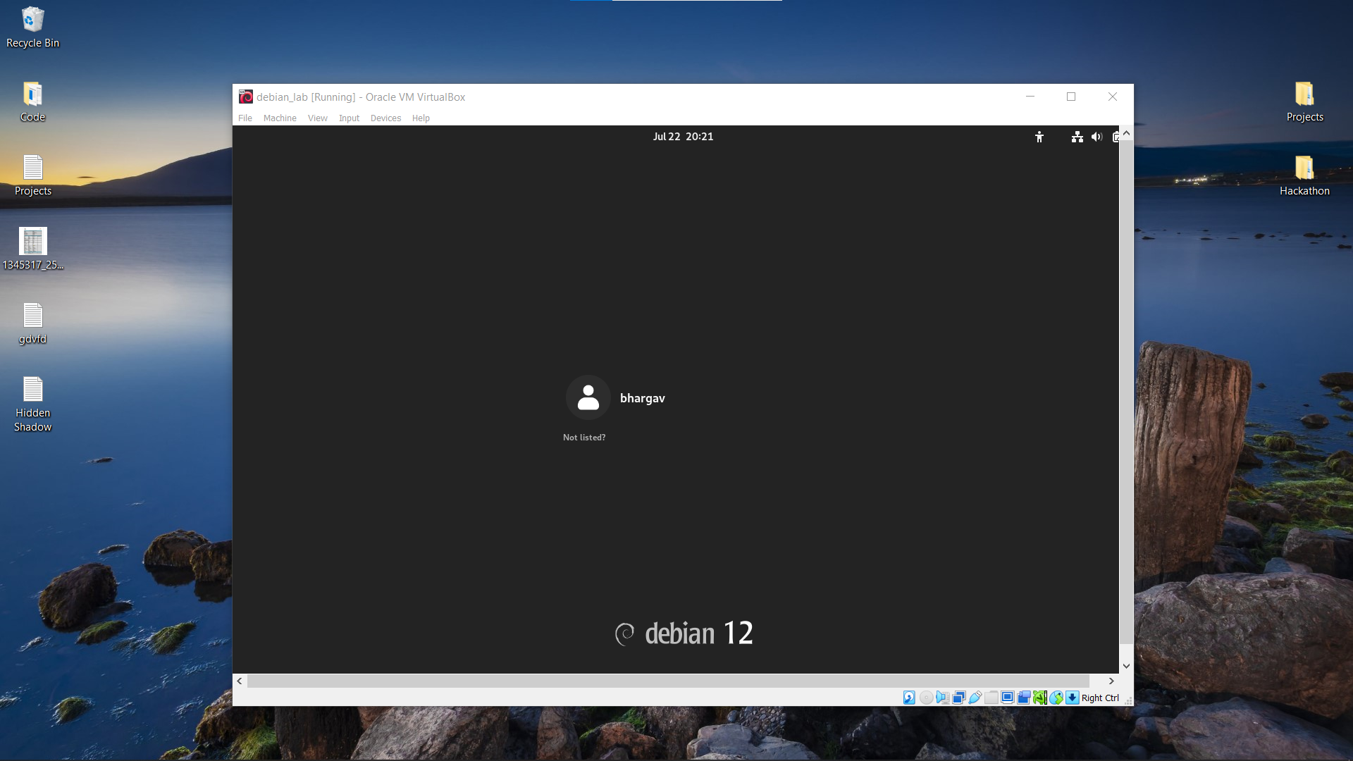

Step 12: Click on user and enter your password you set in previous steps.

1. 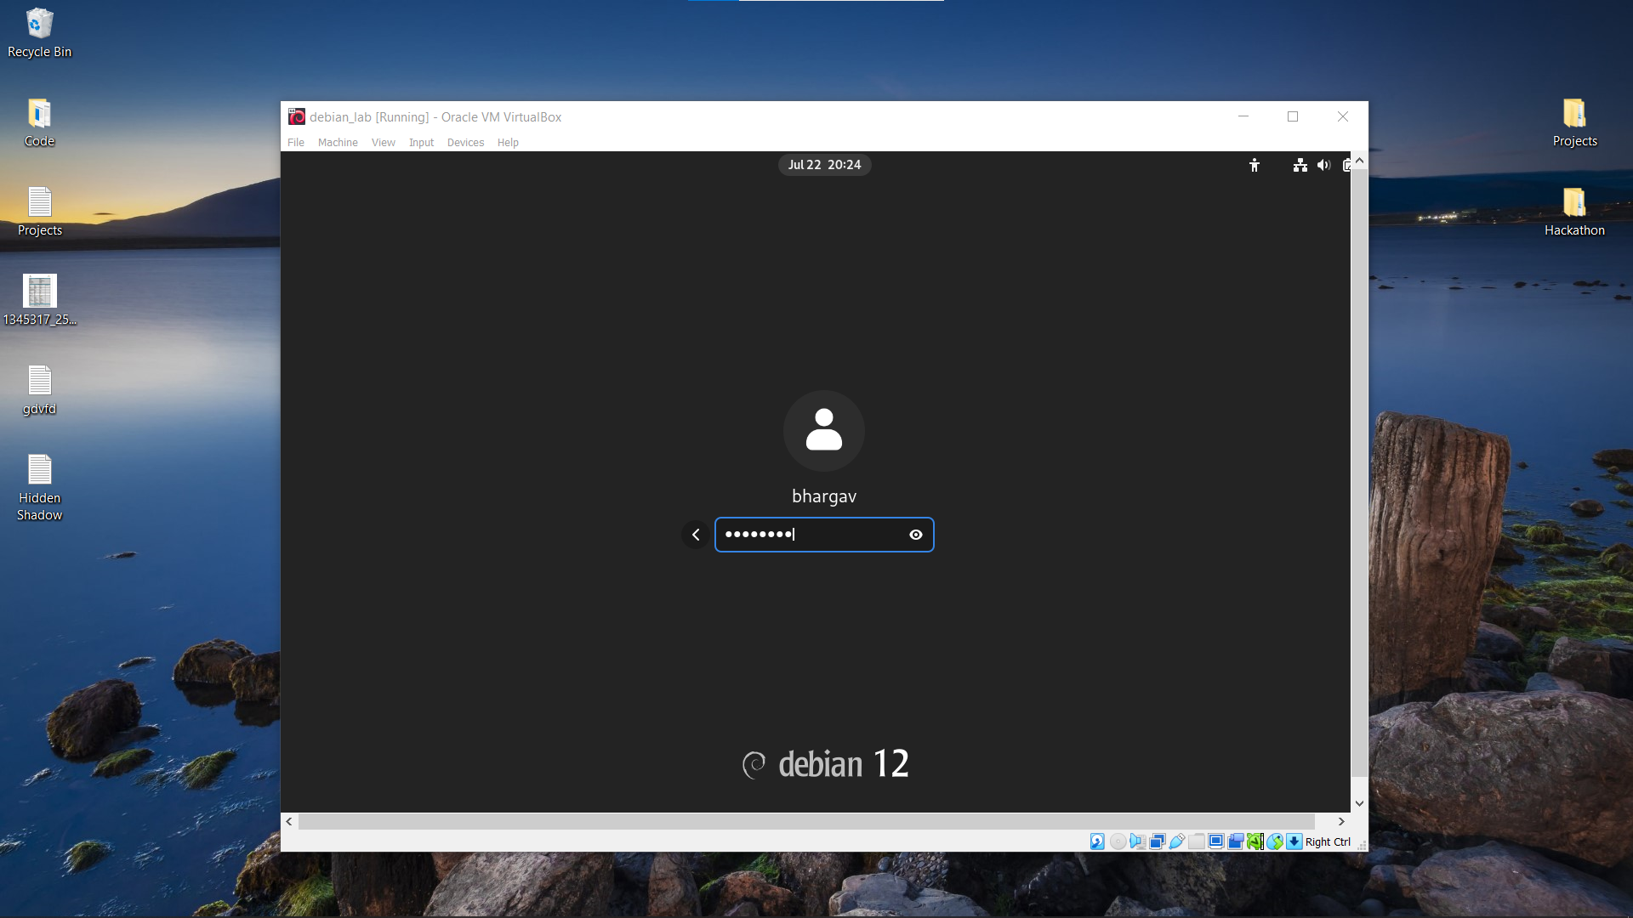

Step 13: Then you must finish basic setups like:

* Keyboard layout.
* Location settings.
* Link online Accounts.
* Then proceed to feel OS.

1. 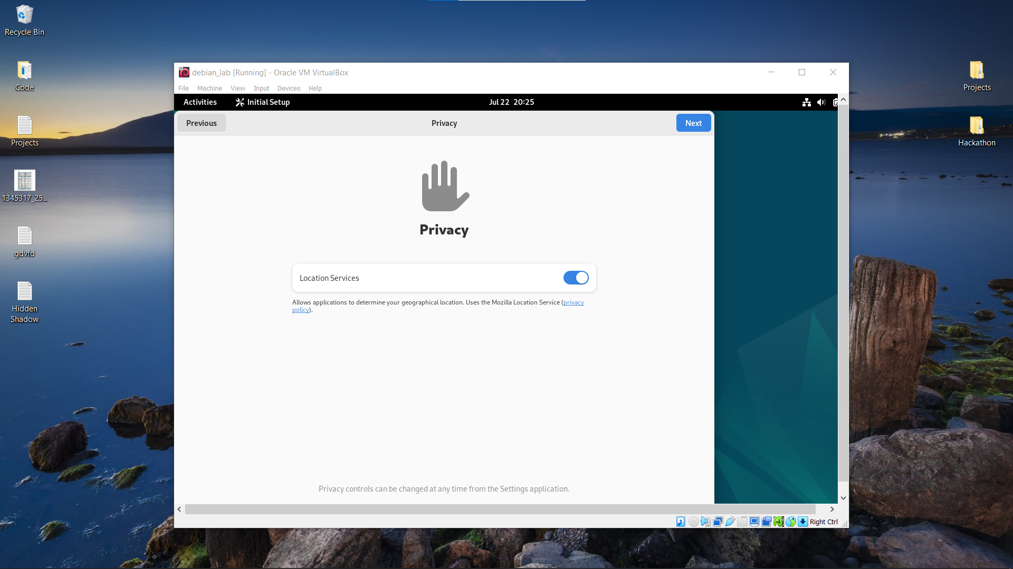
2. 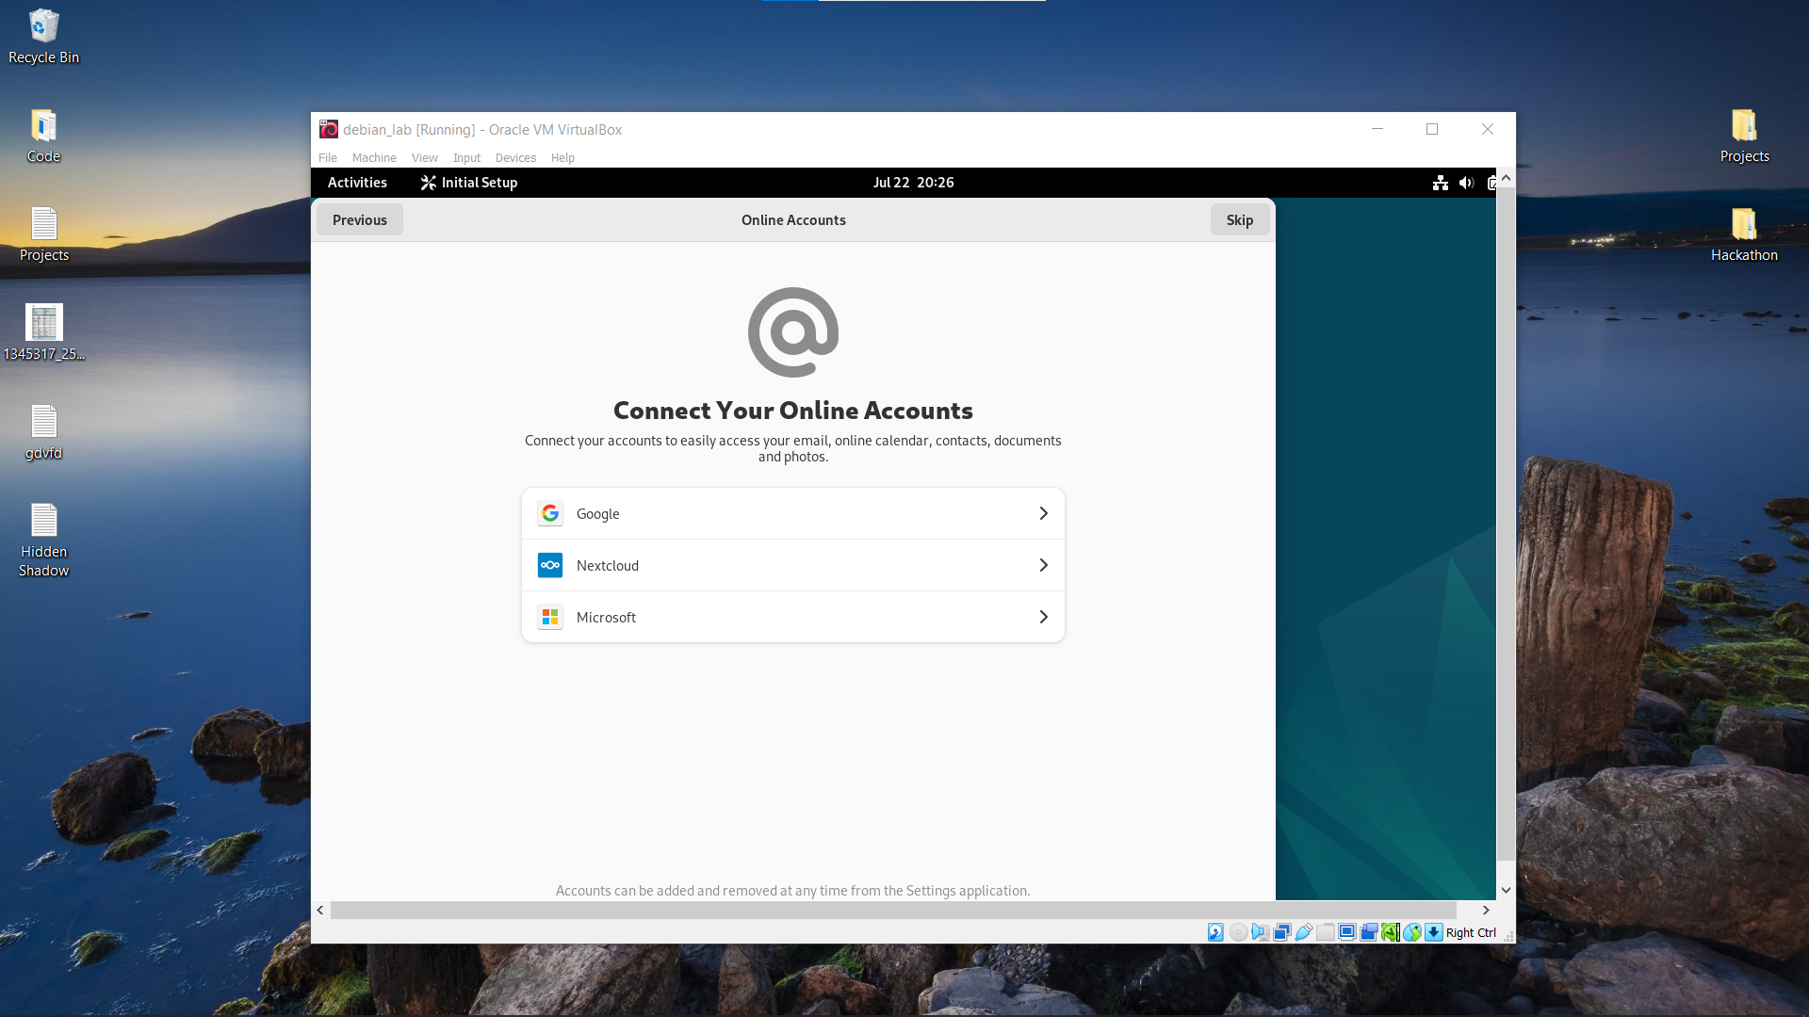
3. 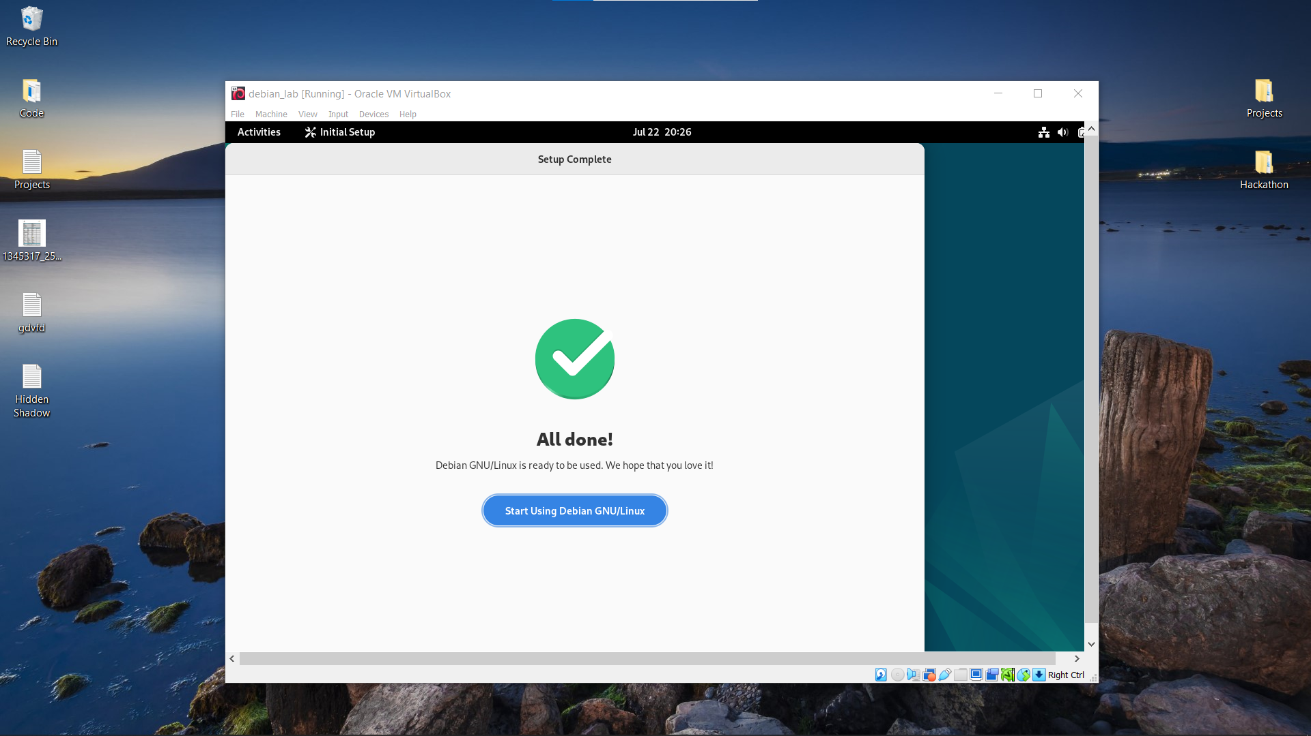
4. 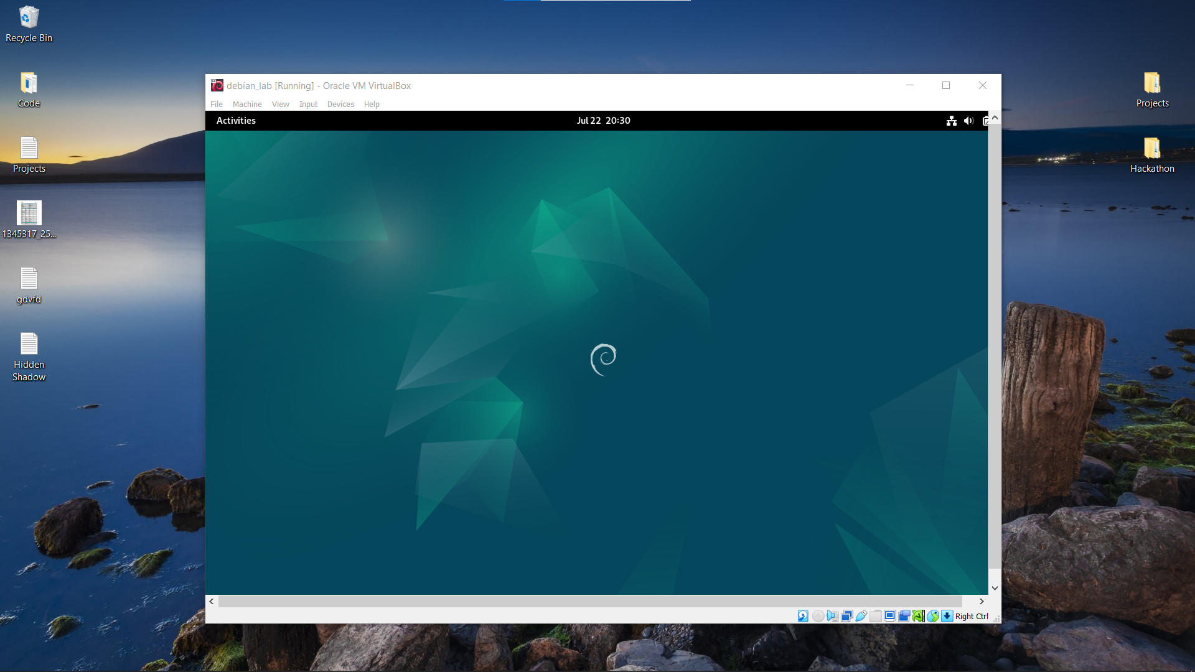

After we comes to this steps, we update package manager and install useful packages in Debian by using terminal.

* Open terminal: type > su
  + Then hit enter,
  + Type > <your_password>
  + Hit enter and type > nano /etc/sudoers
  + Below the line <root ALL=(ALL:ALL) ALL>
    - type <username ALL=(ALL:ALL) ALL>
  + type> ctrl+s and ctrl+x
  + then in terminal type > exit
* Open terminal: type > sudo apt update

**MAKE SURE ALL COMMAND IN TERMINAL CORRECTLY.**

**-----------------------------------------------------------------------------------------**